Ticket-List:

|  |  |  |  |
| --- | --- | --- | --- |
| Ticket | Written | Solved | Time needed |
| Plot_OSLcurve: LM-OSL view |  |  |  |
| Plot_OSLcurve: RadMeas-compatible diagrams |  |  |  |
| New function: divide Input-format |  |  |  |
|  |  |  |  |
|  |  |  |  |
|  |  |  |  |
|  |  |  |  |

**Global data format:**

* All functions use one data.frame format and add (or overwrite) columns

test.components <- data.frame(name = c("fast","medium","slow"), lambda = c(1.5,0.5,0.1), n = c(1000,1000,10000))

Data.frame: **Components**

|  |  |  |  |  |  |  |  |
| --- | --- | --- | --- | --- | --- | --- | --- |
|  | **$name** | **$decay** | **$decay.dev** | **$n** | **$n.error** |  |  |
| 1 | fast | 2 |  | 1000 |  |  |  |
| 2 | medium | 0.5 |  | 1000 |  |  |  |
| 3 | slow | 0.001 |  | 1000 |  |  |  |
| … | background | 0 |  | 10 |  |  |  |

Data.frame **Curve**

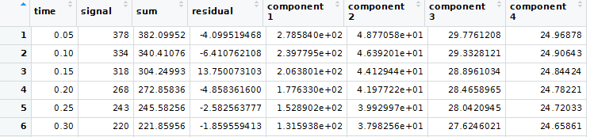

**Example 1:**

>

Comp4.A <- data.frame(name = c("component 1","component 2","component 3","component 4"), lambda = c(3,1,0.3,0.05), n = c(2000,1000,2000,10000))

>

Curv4.A <- simulate_OSLcurve(Comp4.A, channel.width = 0.05, channel.number = 400, simulate.curve = TRUE, add.gaussian.noise = 3, add.background = 5)

>

Comp4.A <- calc_OSLintervals(Comp4.A, Curv4.A)

Maximum determinant = 0.025196 with interval breaking channels [9, 43, 156] found after 960 iterations